Alex Ortunio
Hotel
Project 3

Program design:
Input:
1. location
2. floors
3. total rooms
4. room types
Output:
1. Income
2. Total rooms
3. Occupied rooms
4. Unoccupied rooms
5. Occupancy rate
6. Floor with least number of rooms
7. message about improving occupancy if below 60%
Process/Algorithm:
1. gather input into respective variables/array
2. using a nested for loop calculate total income in addition to all other occupancy based stats
3. Output the data into an ok looking table

screenshot:
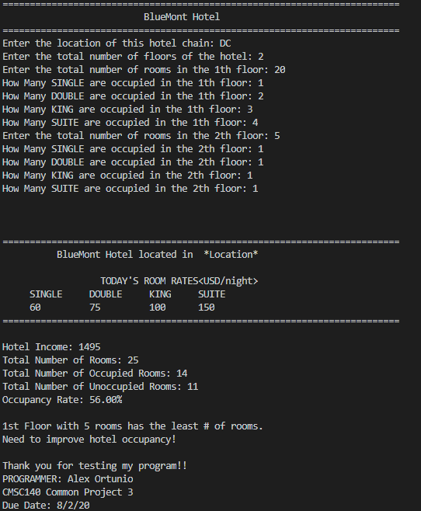

Test Table:
Test Case # | Input | Actual Input | Expected Output | Actual Output | Did the test pass?
1 | 2  5  1  1  1  1  20  1  1  1  1 | 2  5  1  1  1  1  20  1  1  1  1 | 770  25  8  17  32.00% | 770  25  8  17  32.00% | Yes
2 | 2  10  5  5  0  0  20  5  5  5  5 | 2  10  5  5  0  0  20  5  5  5  5 | 2600  30  30  0  100% | 2600  30  30  0  100% | Yes
3 | 1  30  5  5  5  5 | 1  30  5  5  5  5 | 1925  30  20  66.66% | Error thrown | No
4 | 2  10  1  1  1  1  30  1  1  1  17 | 2  10  1  1  1  1  30  1  1  1  17 | 3170  40  24  16  60.00% | 3170  40  24  16  60.00% | Yes

Lesson Learned:
Proper array usage.
Processing data in a language without dynamic typing proved to be a pain, though a good learning experience.
C++ memory management is strange, and much more difficult to use than java.
I need to organize my code more

